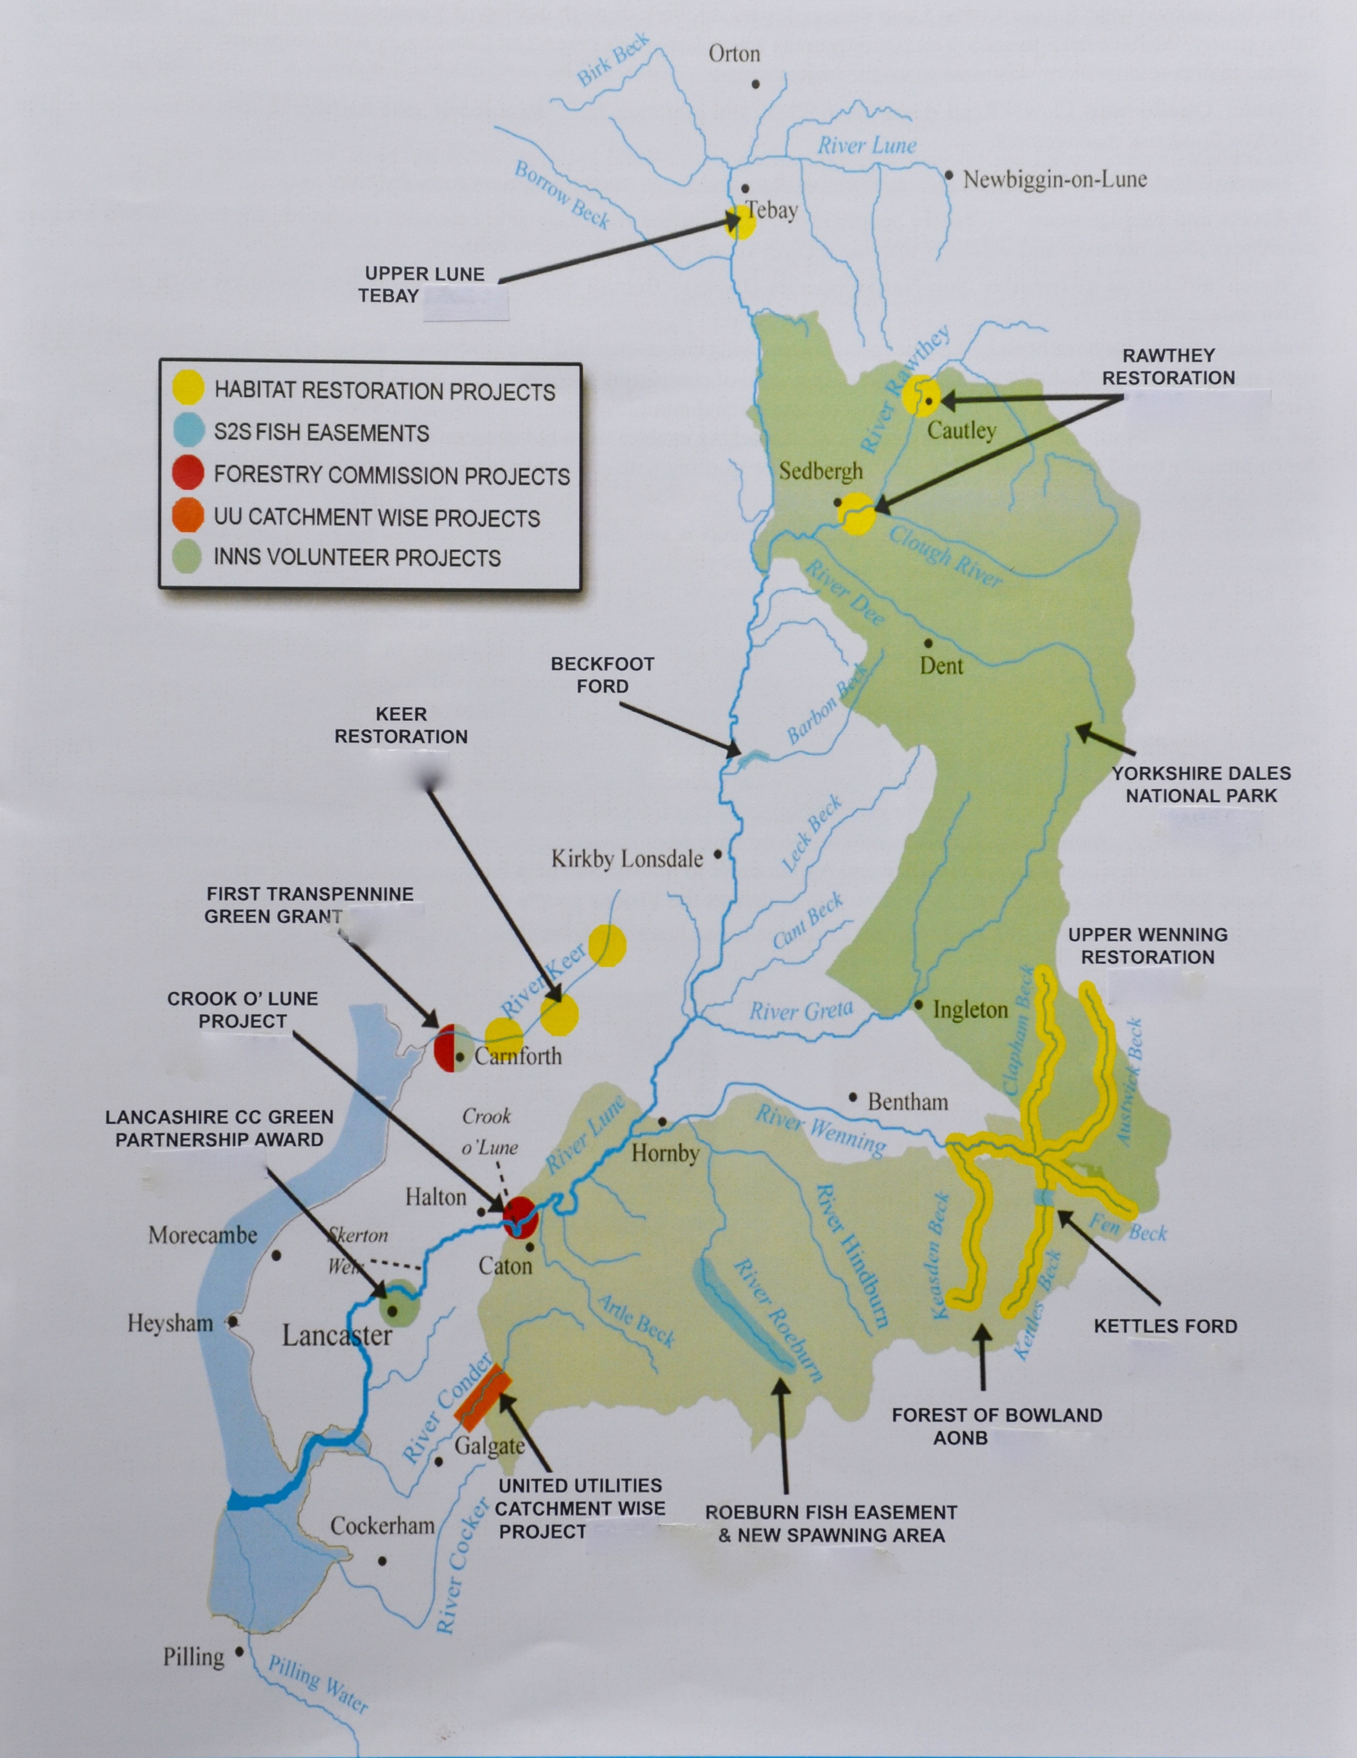 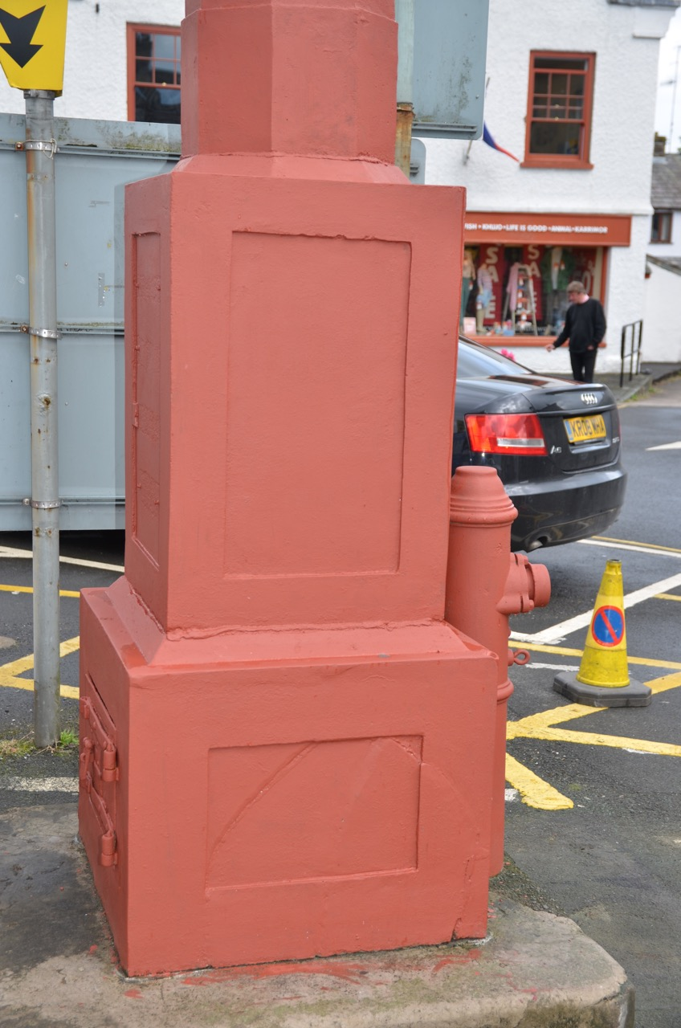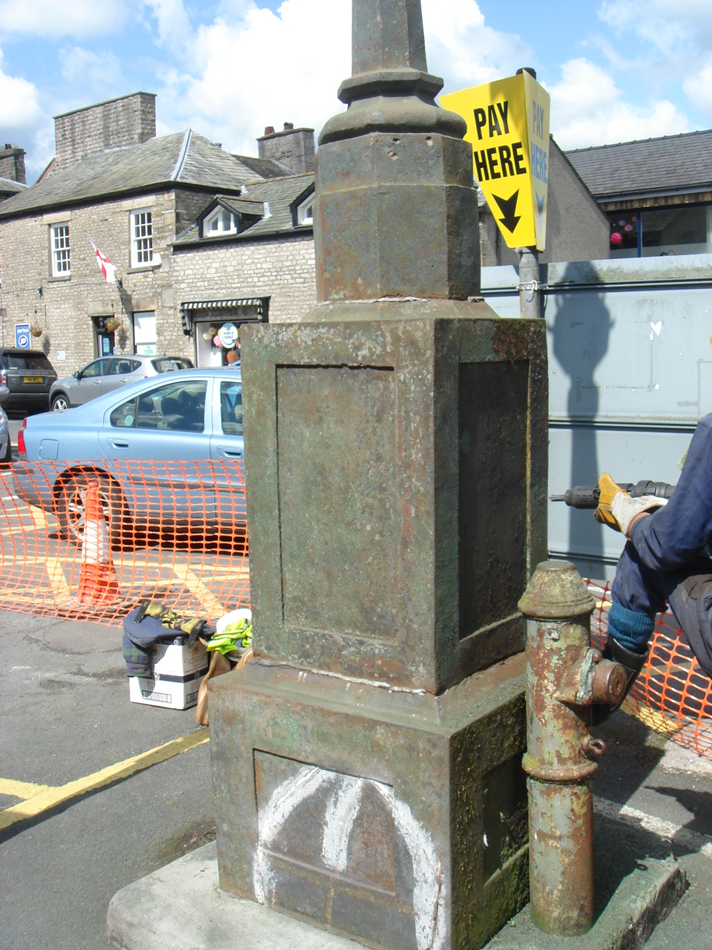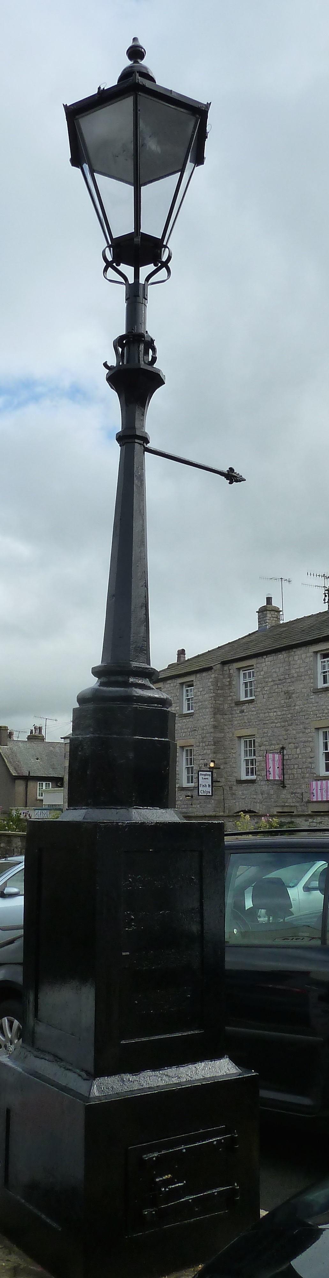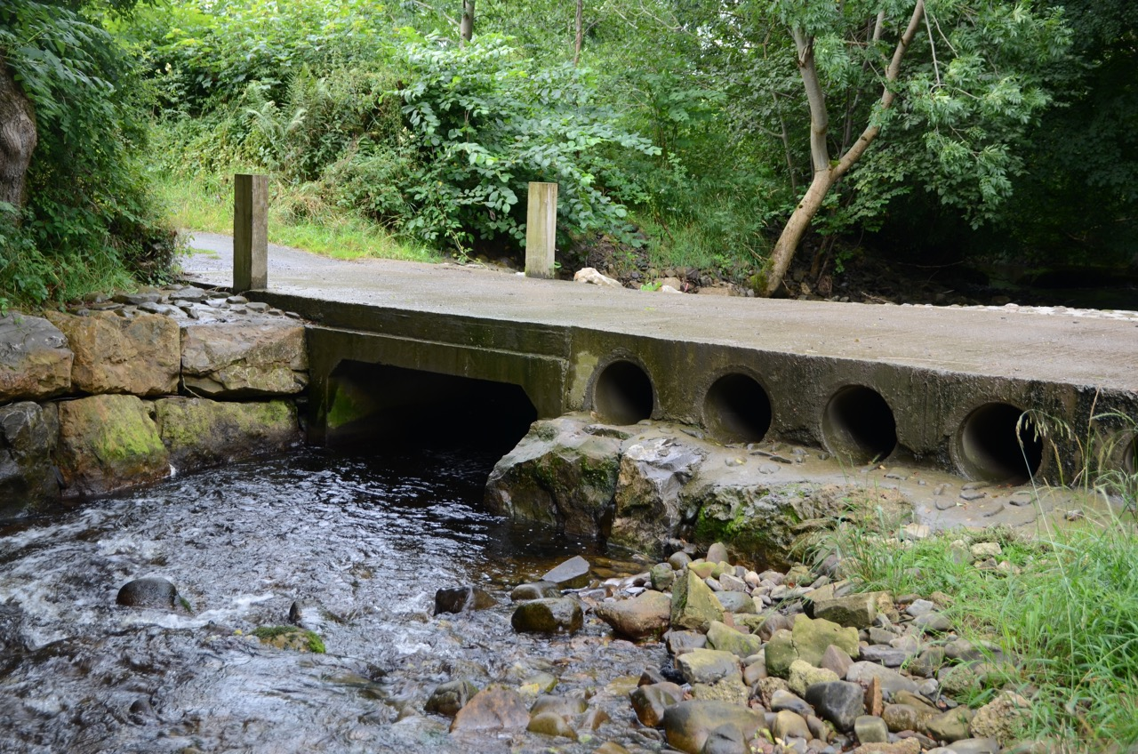 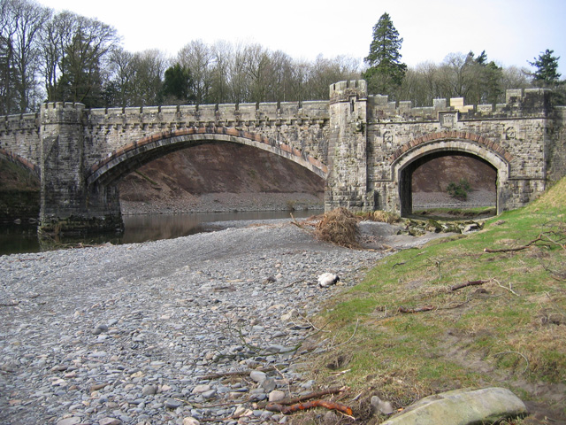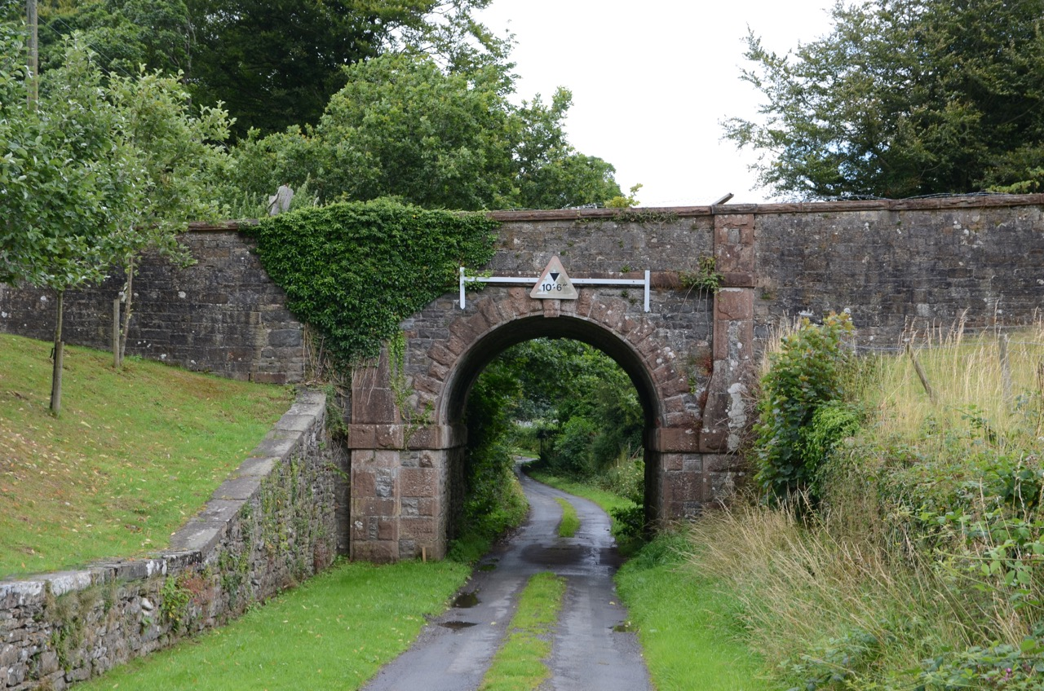

recognized by ENTRUST as an environmental body, has created over 70 habitat sites covering more than 100km of river bank in vulnerable areas. Encouraged by the Environment Agency and others to seek charitable status, The Lune Rivers Trust became a Registered Charity in January 2009.

The diagram shows a dozen of the most recent activities of the Trust throughout the catchment area. Notable amongst projects upstream of Kirkby Lonsdale are:

* 19 km of stock exclusion fencing installed and 3000 trees planted beside the Upper Wenning and its tributaries
* Monitoring and removing INNS (invasive non-native species such as Himalayan Balsam and Japanese Knotweed) in catchment areas within the Yorkshire Dales National Park including the rivers Dee and Clough and within the Forest of Bowland
* Several kms of fencing projects on the upper Lune at Tebay and the River Rawthey
* Monitoring salmon and sea trout movements on a monthly basis since 2010 to assess the impact of improvements
* Opening up of man-made obstacles to allow upstream movement of migratory fish and downstream movement of substrates and gravels including Roeburn Ford near Wray and Beckfoot Ford on Barbon Beck. The latter is at the end of Beckfoot Lane, adjacent to the packhorse bridge (see photograph on page 2)

Downstream there are many other examples of fencing, installing alternative watering points for cattle, INNS

**The Lune Rivers Trust**

When we walk along the lovely stretch of river between Mill Aire and Devil’s bridge, we mostly assume that being pretty clean, full of fish, and with a very diverse habitat of insects birds and mammals is somehow natural - it’s how it’s always been. Think again.

You may not be aware of it, but there is a charity dedicated to the [conservation](http://www.riverconservation.org.uk/projects), [protection](http://www.riverconservation.org.uk/protected-species), [rehabilitation](http://www.riverconservation.org.uk/protected-species) and [improvement of the River Lune](http://www.riverconservation.org.uk/projects) throughout its whole length, as well as its twenty or so tributaries

The aim of the Lune Rivers Trust is to protect and improve the riverine habitat and encourage [biodiversity](http://www.riverconservation.org.uk/projects), and the improving quality of one of Kirkby Lonsdale’s greatest assets is in no small measure thanks to them.

The Trust started life as The Lune Habitat Group. Since 2000 the Group, which was

Contents

* Lune Rivers Trust
* Market Square Lamp-post
* Barbon ‘railway’ bridge
* Planning Matters
* Retail Premises - then and now

*Kirkby Lonsdale & District Civic Society Newsletter - Autumn 2015*

probably moved to its present location when the Monument was built in 1905.

This restoration has revealed damage - a section of the base had been fractured and welded back into place - which probably happened during the move. The next task is to try and remove some of the street clutter around it.

**Market Square Lamp-post**

The Victorian lamp-post in Market Square has been looking decidedly sorry for itself for a long time. Now thanks to a project funded jointly by the Civic Society and Cumbria County Council it is looking cared for again. The specialist contractor we employed to carry out the work

* Removed paint residues and rust, cleaning back to bare metal with a needle gun then smoothed back with wire cup brushes in an angle grinder
* Primed in Zinc Phosphate, applied a thick coat of UPF beige, a primer filler coat, which provides good protection, followed by the final black coats
* Fitted a new lantern, appropriate to the period but with a low energy LED lamp.

The age of the lamp is uncertain, but it was originally a gas lamp. We have a photograph from 1855 showing it in place opposite the entrance to the Royal Hotel, which would fit with the opening of the Kirkby Lonsdale Gas Works in 1850. It was

£18,000 from the Environment Agency, £100,000 from DEFRA, and smaller amounts from United Utilities, Forestry Commission, Yorkshire Dales National Park, and Lancashire County Council, and donations from many angling clubs, businesses and individuals. Last but not least the Trust does its own fund-raising, including a special steam railway excursion on October 3rd 2015 going to York and an Auction of Promises.

The website [www.luneriverstrust.org.uk](http://www.luneriverstrust.org.uk) has much more information, as well as details of a membership scheme for any individual or business who would like to support the Trust. The Auction of Promises (which in 2012 raised over £12,000) is at the Scarthwaite Hall Hotel in Caton on November 20th starting at 7.30pm.

*The editor is grateful to the Lune Rivers Trust for permission to use the diagram*

treatment, and obstacle removal. Monitoring includes kingfisher numbers, and the first detailed surveys of sea trout - spawning areas, numbers and identification of habitat issues.

Work is carried out by contractors and by volunteers and more of the latter are always needed!

All this costs money. In 2015 nearly £180,000 was raised for specific projects, including

the northbound A683. The builder is unknown but it certainly has a look of railway architecture about it. A much bigger problem for this new access was the crossing of the River Lune, which was achieved between 1872 and 1875 by the creation of Underley Bridge (Grade 2-listed and possibly designed by Paley and Austin), so it is reasonable to assume that the ‘railway bridge’ was built at about the same time. Creating this short cut to the railway station must have been a substantial expense, but the owners of Underley Hall were wealthy people!

**Planning Matters**

**SL/2015/0586 - The Old Weigh House, Kirkby Lonsdale**

This building will occupy a key location in one of the most characterful areas of the Kirkby Lonsdale Conservation Area.

The overall design is sympathetic to its setting, but we made the following comments:

1. The two short external flights of steps should be retained with minimal change other than to repair them and make them safe.
2. The existing cobblestones should continue to abut the whole length of the new property.
3. The existing doors at the top of the 2 short flights of steps are to be replaced by windows. The suggested design of these is quite out of keeping with the rest of the building and its surroundings, and we recommend a more sympathetic design is found.
4. The ground floor entrance into the hall - which appears to comprise a glass door, glass panel to side and four glazed units above - is incongruous and again it is hoped a more sympathetic solution can be found.
5. Stained timber cladding to infill the window openings on the main east elevation is inappropriate. If they could be louvred it would reference the former use of the building.

**SL/2015/0689 - 41 Mitchelgate, Kirkby Lonsdale**

This application was concerned mainly with changes to fenestration on the north side overlooking Lower Abbotsgate. In our view the proposed new window to the gable end is out of character with the building. Although previously used as a mill, this building has never had a 'warehouse style' full height opening for goods and we feel that to add this feature would just be a pastiche.

**SL/2015/0749 - Abbots Brow, Kirkby Lonsdale.**

Although this is not a listed building it is in a prominent position in the Conservation Area, forms part of the east side of the churchyard and is opposite the Grade 1 listed Church. We objected to the modern north facing flat roof extension, the glass box window on the north elevation and the changes to the fenestration (especially the loss of the attractive tall arched window) on the west side. All would detract from the

**The ‘Railway Bridge’ that never was.**

Anyone passing down Beckfoot Lane in Barbon could be forgiven for thinking that the bridge they are about to pass beneath is one of the many railway bridges remaining from the Ingleton branch line to Tebay, which was completed in 1861 (and closed to passengers in 1954).

Not so. It was built by the owners of Underley Hall as part of their provision for a level access to the railway station at Barbon, and to

character of the building, and introduce jarring modern elements without the saving grace of good design and materials. We also queried the loss of the stone piered garden gate, and in view of the nature of the site suggested an archaeological study before works commenced.

|  |  |  |  |
| --- | --- | --- | --- |
| **Editor:** Dr Ken Humphris  The views expressed are those of the Editor and do not necessarily reflect those of the Civic Society Committee as a whole. The Editor would be delighted to receive comments or articles from members of the Society for inclusion in the newsletter.  Registered Charity No. 502315 | **Committee**  Chairman  Dr Ken Humphris  Lowgill, High Casterton  LA6 2SD  Tel: 015242 71983  **Secretary**  Mrs Sue Pelter  The Garden House, 12 Mill Brow, Kirkby Lonsdale , LA6 2AT  Tel: 015242 73824 | **Membership Secretary**  Mrs Judith Manifold  Tel: 015242 73457  **Treasurer**  Mr David Dalgoutte  Delph cottage  Jingling Lane  Kirkby Lonsdale  LA6 2AW  Ms Lynne Seignot  Tel: 015242 76434 | Mr Peter Stockdale  Tel: 015242 76443  Mr Tom Felix  Tel: 015242 72248  Miss Pat France  Tel: 015242 71740  Mrs Audrey Phillips  Tel: 015242 72514 |

This is not a definitive analysis as it only considers those businesses advertising in the local press at that time, but nonetheless nearly 20% of the premises existing 60 years ago still offer the same products (shown highlighted) albeit in every case with different proprietors. There are now more hairdressers and clothes shops, and fewer butchers and grocers than in 1955.

**Retail premises in Kirkby Lonsdale 1955 to 2015**

A copy of the ‘Kirkby Lonsdale Advertiser and Local News’ for May 1955, seen recently in the library, caught the Editor’s eye. It comprised mainly small advertisements for local businesses and it is interesting to compare those with the retailers now occupying the same addresses.

|  |  |  |
| --- | --- | --- |
|  | **Advertising in 1955** | **Now** |
| **Market Street** | Decorators (James Dennison) | Opticians (Collinge) |
|  | Bookshop | Ladieswear (Brief Encounter) |
|  | Ladieswear (Emma) | Café (Copper Kettle) |
|  | Glass, china, fancy goods (Jamieson) | Menswear (Lawrie Barrie) |
|  | Shoe repairs (S & J Martin) | Carpets (Carpet Inn) |
|  | Fancy goods/printer (A Willan) | Ladieswear (Foxy Lady) |
|  | Jewellers (C Preston) | (Number 15) |
|  | Household Goods (F M Tanner) | Ladieswear (Spotty Hen) |
| **Main Street** | Inn (Red Dragon) | Inn (Red Dragon) |
|  | Shoeshop (W Fisher) | Home furnishings (Just ‘n’ So) |
|  | Grocer/seedsman (John Dean) | Greetings cards (The Card Gallery) |
|  | Butcher (J Wane) | JJ (Hairdresser) |
|  | Builder (F Cornes) | Private house |
|  | Café (Old English Tearooms) | Tiles (Pure Stone) |
|  | Lonsdale Bakery | Lonsdale Bakery |
|  | Riding equipment/leather goods (T Fawcett) | Menswear (Bells) |
|  | Electrical appliances (H C Wearing) | Bar/restaurant (Avanti) |
|  | Butcher (R Robinson) | Spar |
|  | Menswear (J Wolfenden) | Homewear, toys, gifts (Parma Violet) |
| **Market Square** | Café (Vale of Lune Snack Bar) | Café/restaurant (Crossing Point) |
|  | Chemist (H&M Evans) | Chemist (Boots) |
|  | Sweetshop | Sweetshop |
| **Jingling Lane** | Fish and chip shop | Fish and chip shop |
| **Beckhead** | Greengroceries, fish (G G Carling) | Hairdressers (Headline) |
|  | Café (Corner Café) | Private house |
| **Millbrow** | Newsagent (Willans) | B&B (Blue Pig) |
|  | Garage (Mill Brow Garage) | Dwellings |
| **Salt Pie Lane** | Greengrocers (E Billington) | Private house |
| **Mitchelgate** | Bakers ( P&D Howarth) | Private house |